First, read the brief passage at: http://www.ducksters.com/history/native_american_tribes_regions.php.

Then, look below. Follow the links to help you fill in your graphic organizers! Be sure to read the link fully and complete your organizer! Each group is responsible for their part of the graphic organizer but you will have to fill the entire organizer out when groups present. If you finish your groups’ early, begin discovering information about the other groups.

Navajo- http://www.ducksters.com/history/native_american_navajo.php
Religion- http://www.everyculture.com/North-America/Navajo-Religion-and-Expressive-Culture.html

Iroquois- http://www.ducksters.com/history/native_american_iroquois.php

Religion- http://www.everyculture.com/North-America/Iroquois-Religion-and-Expressive-Culture.html

Cherokee- http://www.ducksters.com/history/native_american_cherokee.php
Religion - http://www.religious-beliefs.com/cherokee-indian-religion.htm

Inuit- http://www.ducksters.com/history/native_americans/inuit_peoples.php
Religion- http://firstpeoplesofcanada.com/fp_groups/fp_inuit5.html

Lenape- http://www.lenapelifeways.org/lenape1.htm
Religion- http://classroom.synonym.com/religion-beliefs-lenape-indians-5231.html

Pueblo- http://www.ducksters.com/history/native_americans/pueblo_tribe.php
Religion- http://nativeamericans.mrdonn.org/southwest/puebloreligion.html
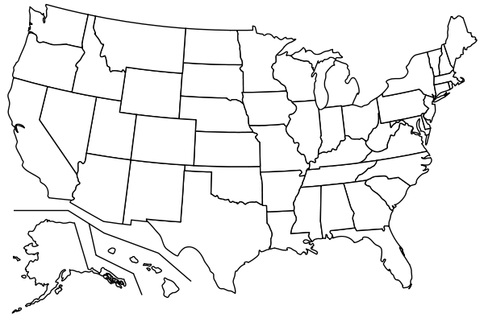
Name of Group | Geographic Location- Where do they live? | Describe their dwellings/homes. | Religion/Spiritual Belief | Describe their method of hunting or agriculture
Iroquois
Cherokee
Inuit

Lenape
Pueblo

